

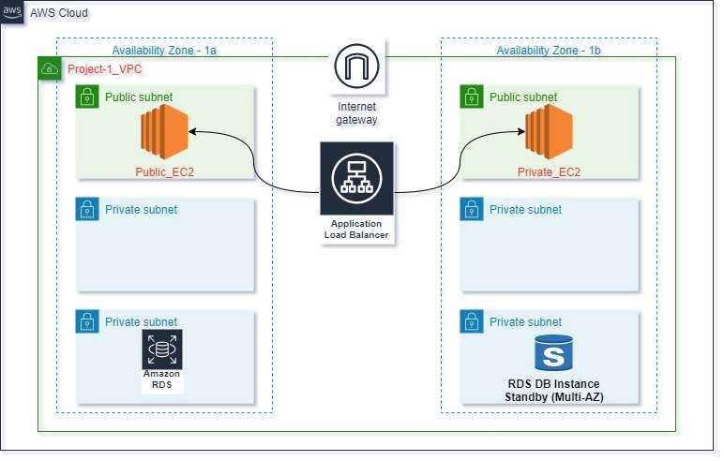

Deploy Three-tier Application In AWS using Terraform







